TASK :01

Write a C++ Program that read a float (amount) and an int (num) input from user. Add both (amount and num) numbers and store them in two different int (a) and float (b) variables. Display the outputs of a and b variables. Also if outputs are greater than 16 print “value of a & b > 16” else print “value of a & b < 16”.

**Source Code:**

#include<iostream>

using namespace std;

int main()

{

//declaring variables:

float amount,b;

int num,a;

//Enter float and integer num:

cout<<"Enter any float number: ";

cin>>amount;

cout<<"\n"<<"Enter any integer number: ";

cin>>num;

//add float and integer num:

a=amount+num;

b=amount+num;

//Output of sum:

cout<<"\n"<<"Output in float: "<<b<<endl;

cout<<"\n"<<"Output in integer: "<<a<<endl;

if(a>16 && b>16)

{

cout<<"\n"<<"Value of a & b > 16"<<endl;

}

else

{

cout<<"\n"<<"Value of a & b < 16"<<endl;

}

return 0;

}

Snapshot:

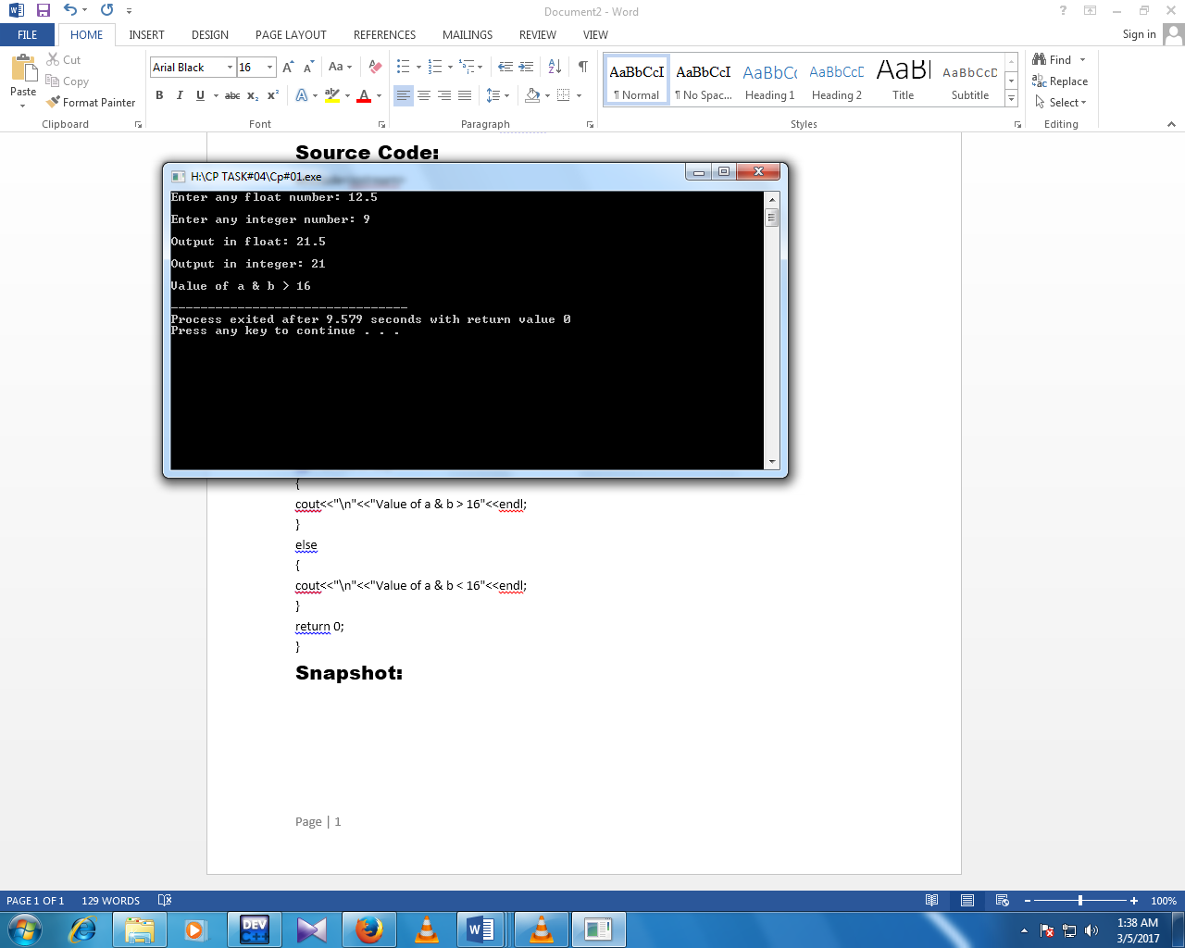

TASK :02

Write a C++ Program that read three input from user and returns the smallest one.

**Source Code:**

#include<iostream>

using namespace std;

int main()

{

//Declaring variables:

int a,b,c;

//Enter values of a,b and c:

cout<<"Enter value of 'a': ";

cin>>a;

cout<<"\n"<<"Enter value of 'b': ";

cin>>b;

cout<<"\n"<<"Enter value of 'c': ";

cin>>c;

//apply condition:

if(a<b && a<c)

{

cout<<"\n"<<"The smallest one is: "<<a<<endl;

}

else if(b<a && b<c)

{

cout<<"\n"<<"The smallest value is: "<<b<<endl;

}

else

{

cout<<"\n"<<"The smallest one is: "<<c<<endl;

}

}

Snapshot:

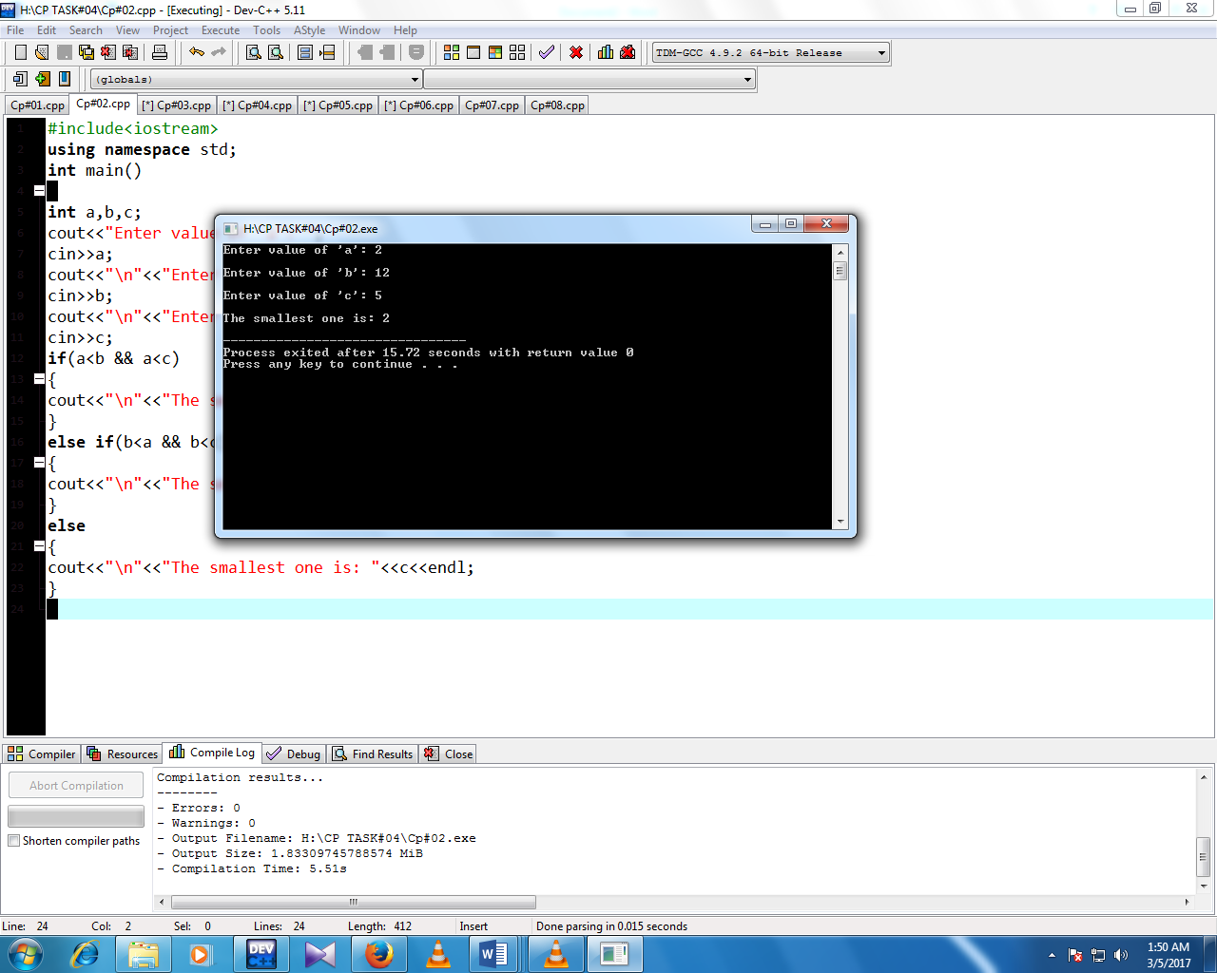

TASK :03

Write a C++ Program that read an alphabet (e.g. a,b,c,d,…..z) and display whether the input alphabet is a vowel (i.e. a, e, i, o, u) or consonant.

**Source Code:**

#include<iostream>

using namespace std;

int main()

{

//Declaring variables:

char alph,a,e,i,o,u;

//Enter alphabet:

cout<<"Enter any alphabet: ";

cin>>alph;

//Apply condition:

if(alph=='a' || alph=='e' || alph=='i' || alph=='o' || alph=='u')

{

cout<<"\n"<<"The alphabet is vovel"<<endl;

}

else

{

cout<<"\n"<<"The alphabet is not vovel"<<endl;

}

return 0;

}

Snapshot:

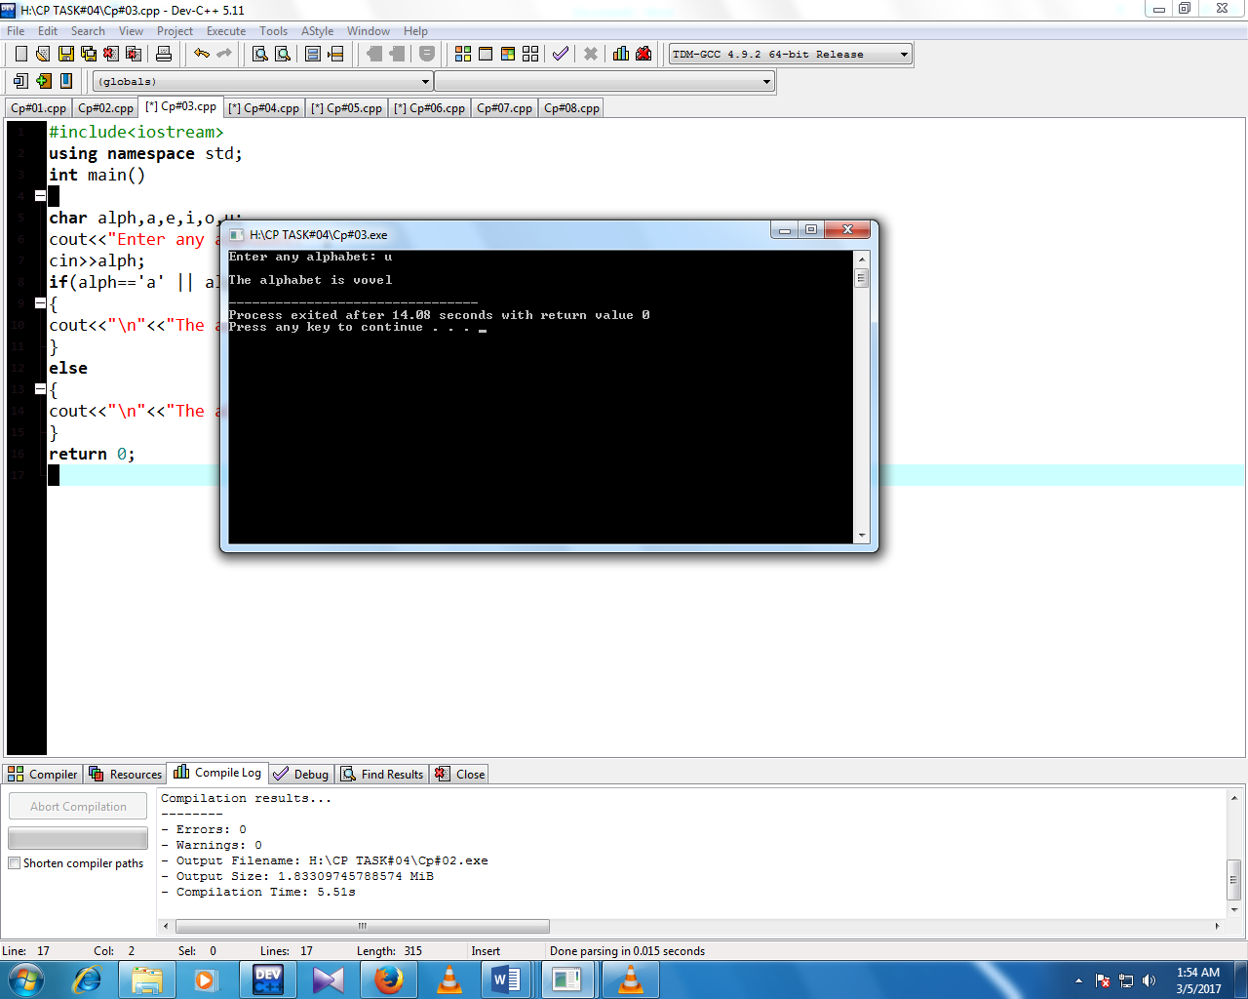

TASK :04

Write a C++ Program that read a number from user .Test the user entered number whether it is EVEN or ODD. Print the message that number is EVEN or ODD.

**Source Code:**

#include<iostream>

using namespace std;

int main()

{

//Declaring variables:

int num1,num;

//Enter num:

cout<<"Enter any integer number: ";

cin>>num;

num1=num%2;

//Apply condition:

if(num1==0)

{

cout<<"\n"<<"The Entered num is even"<<endl;

}

else

{

cout<<"\n"<<"The Entered num is odd"<<endl;

}

}

Snapshot:

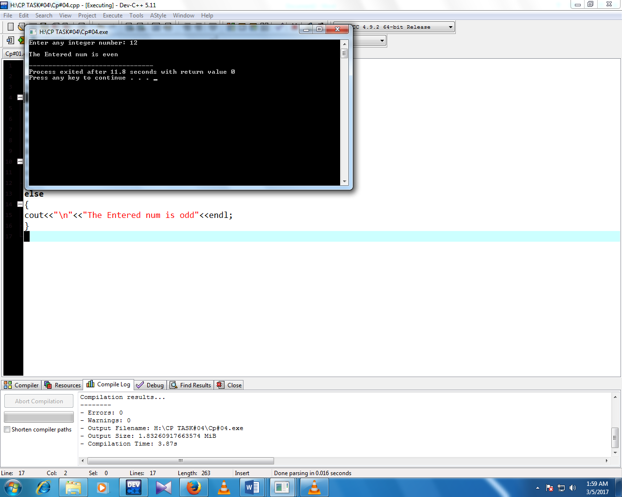

TASK :05

Write a C++ Program that read an integer input in between (1 to 12) and store it *month_of_year.* Print the corresponding month of year. Use *else if* statement.

Eample: Input is 4… Print “April”

**Source Code:**

#include<iostream>

using namespace std;

int main()

{

//Declaring variables:

int mon;

cout<<"Enter any integer num between (1 to 12): ";

cin>>mon;

//Apply condition:

if(mon==1)

{

cout<<"\n"<<"The month of year is: January "<<endl;

}

else if(mon==2)

{

cout<<"\n"<<"The month of year is: February "<<endl;

}

else if(mon==3)

{

cout<<"\n"<<"The month of year is: March "<<endl;

}

else if(mon==4)

{

cout<<"\n"<<"The month of year is: April "<<endl;

}

else if(mon==5)

{

cout<<"\n"<<"The month of year is: May "<<endl;

}

else if(mon==6)

{

cout<<"\n"<<"The month of year is: June "<<endl;

}

else if(mon==7)

{

cout<<"\n"<<"The month of year is: July "<<endl;

}

else if(mon==8)

{

cout<<"\n"<<"The month of year is: August "<<endl;

}

else if(mon==9)

{

cout<<"\n"<<"The month of year is: September "<<endl;

}

else if(mon==10)

{

cout<<"\n"<<"The month of year is: October "<<endl;

}

else if(mon==11)

{

cout<<"\n"<<"The month of year is: November "<<endl;

}

else if(mon==12)

{

cout<<"\n"<<"The month of year is: December "<<endl;

}

else

{

cout<<"\n"<<"Its not a Month of year";

}

return 0;

}

Snapshot:

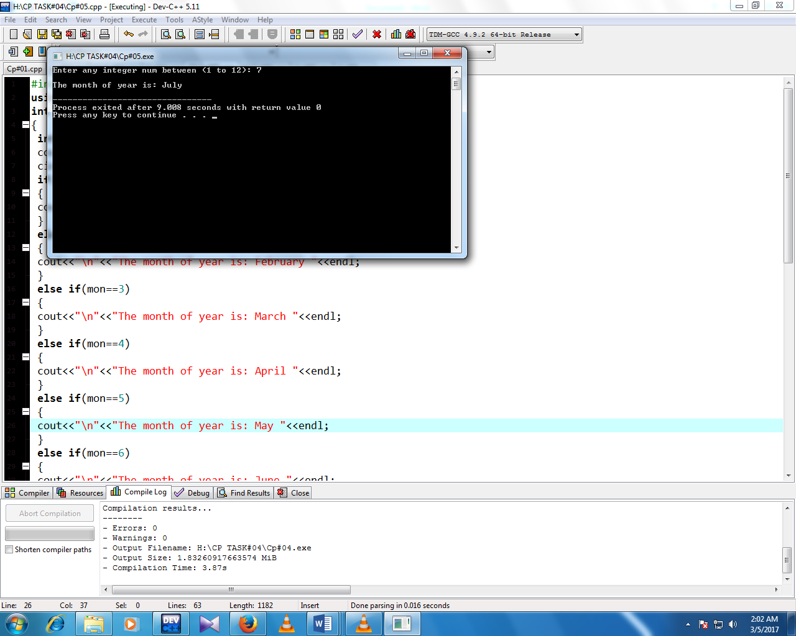

TASK :06

Rewrite exercise 5 using *switch* statement.

**Source Code:**

#include<iostream>

using namespace std;

int main()

{

//Declaring variables:

int mon;

cout<<"Enter any num between (1 to 12): ";

cin>>mon;

//Apply condition:

switch(mon)

{

case 1:

cout<<"\n"<<"The month of year is: January";

break;

case 2:

cout<<"\n"<<"The month of year is: February";

break;

case 3:

cout<<"\n"<<"The month of year is: March";

break;

case 4:

cout<<"\n"<<"The month of year is: April";

break;

case 5:

cout<<"\n"<<"The month of year is: May";

break;

case 6:

cout<<"\n"<<"The month of year is: June";

break;

case 7:

cout<<"\n"<<"The month of year is: July";

break;

case 8:

cout<<"\n"<<"The month of year is: August";

break;

case 9:

cout<<"\n"<<"The month of year is: September";

break;

case 10:

cout<<"\n"<<"The month of year is: October";

break;

case 11:

cout<<"\n"<<"The month of year is: November";

break;

case 12:

cout<<"\n"<<"The month of year is: December";

}

return 0;

}

Snapshot:

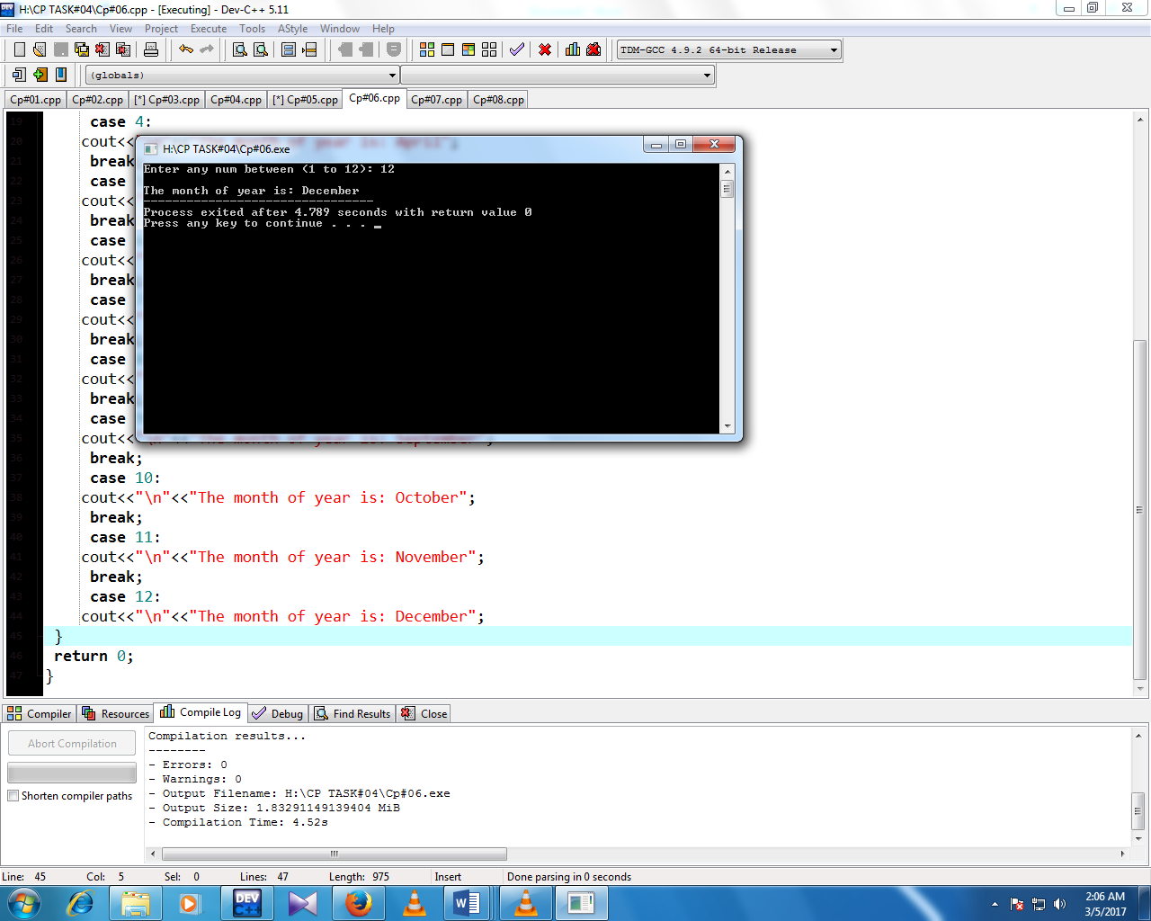

TASK :07

Write a C++ Menu driven program that allows a user to enter 3 numbers and then choose between findings the smallest, largest, sum or average. Use else if statement to determine what action to take.

**Source Code:**

#include<iostream>

using namespace std;

int main()

{

//declaring variables:

float a,b,c;

int op;

//Enter values:

cout<<"Enter any three values:"<<endl;

cin>>a>>b>>c;

cout<<"\n"<<"'1' for Smallest: "<<endl;

cout<<"\n"<<"'2' for Largest:"<<endl;

cout<<"\n"<<"'3' for Sum:"<<endl;

cout<<"\n"<<"'4' for Average:"<<endl;

cout<<"\n"<<"Enter one of the above choices: ";

cin>>op;

//For smallest number:

if(op==1 && a<b && a<c)

{

cout<<"\n"<<"The smallest num is: "<<a<<endl;

}

else if(op==1 && b<a && b<c)

{

cout<<"The smallest num is: "<<b<<endl;

}

else if(op==1 && c<a && c<b)

{

cout<<"\n"<<"The smallest num is: "<<c<<endl;

}

//For largest number:

else if(op==2 && a>b && a>c)

{

cout<<"\n"<<"The largest num is: "<<a<<endl;

}

else if(op==2 && b>a && b>c)

{

cout<<"\n"<<"The largest num is: "<<b<<endl;

}

else if(op==2 && c>a && c>b)

{

cout<<"\n"<<"The largest num is: "<<c<<endl;

}

//For Sum:

else if(op==3)

{

cout<<"\n"<<"Sum of Values are:"<< a+b+c<<endl;

}

//For Average:

else if

(op==4)

{

cout<<"\n"<<"Avearage of Values are: "<<(a+b+c)/3<< endl;

}

else

{

cout<<"\n"<<"Enter correct numbers"<<endl;

}

return 0;

}

Snapshot:

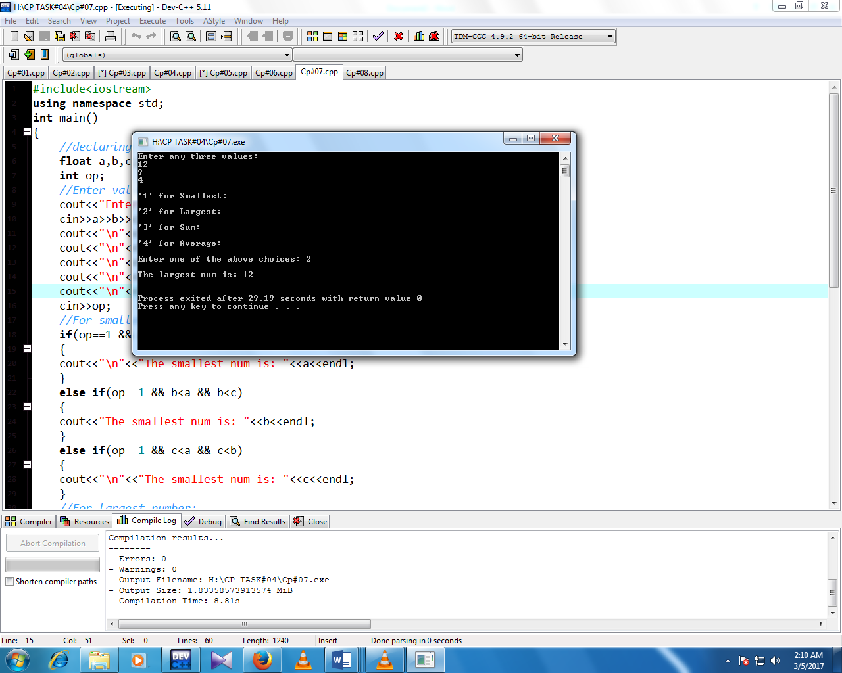

TASK :08

Rewrite exercise 7 using *switch* statement

**Source Code:**

#include<iostream>

using namespace std;

int main()

{

//declaring variables:

float a,b,c;

int op;

//Enter values:

cout<<"Enter any three values:"<<endl;

cin>>a>>b>>c;

cout<<"\n"<<"'1' for Smallest: "<<endl;

cout<<"\n"<<"'2' for Largest:"<<endl;

cout<<"\n"<<"'3' for Sum:"<<endl;

cout<<"\n"<<"'4' for Average:"<<endl;

cout<<"\n"<<"Enter one of the above choices: ";

cin>>op;

switch(op)

{

//For smallest number:

case 1:

if(a<b && a<c)

cout<<"\n"<<"The smallest num is: "<<a<<endl;

else if(b<a && b<c)

cout<<"The smallest num is: "<<b<<endl;

else if(c<a && c<b)

cout<<"\n"<<"The smallest num is: "<<c<<endl;

break;

//For largest number:

case 2:

if(a>b && a>c)

cout<<"\n"<<"The largest num is: "<<a<<endl;

else if(b>a && b>c)

cout<<"\n"<<"The largest num is: "<<b<<endl;

else if(c>a && c>b)

cout<<"\n"<<"The largest num is: "<<c<<endl;

break;

//For Sum:

case 3:

cout<<"\n"<<"Sum of Values are:"<< a+b+c<<endl;

break;

//For Average:

case 4:

cout<<"\n"<<"Avearage of Values are: "<<(a+b+c)/3<< endl;

break;

}

return 0;

}

Snapshot:

